## **Project 01 - 1 Hour**

## **Deploying a Scalable Web Application with Persistent Storage and Advanced Automation**

### **Objective:**

Deploy a scalable web application using Docker Swarm and Kubernetes, ensuring data persistence using a single shared volume, and automate the process using advanced shell scripting.

### **Overview:**

1. **Step 1**: Set up Docker Swarm and create a service.
2. **Step 2**: Set up Kubernetes using Minikube.
3. **Step 3**: Deploy a web application using Docker Compose.
4. **Step 4**: Use a single shared volume across multiple containers.
5. **Step 5**: Automate the entire process using advanced shell scripting.

### **Step 1: Set up Docker Swarm and Create a Service**

#### **1.1 Initialize Docker Swarm**

#### **1.2 Create a Docker Swarm Service**

### **Step 2: Set up Kubernetes Using Minikube**

#### **2.1 Start Minikube**

#### **2.2 Deploy a Web App on Kubernetes**

Create a deployment file named webapp-deployment.yaml:

Apply the deployment:

kubectl apply -f webapp-deployment.yaml

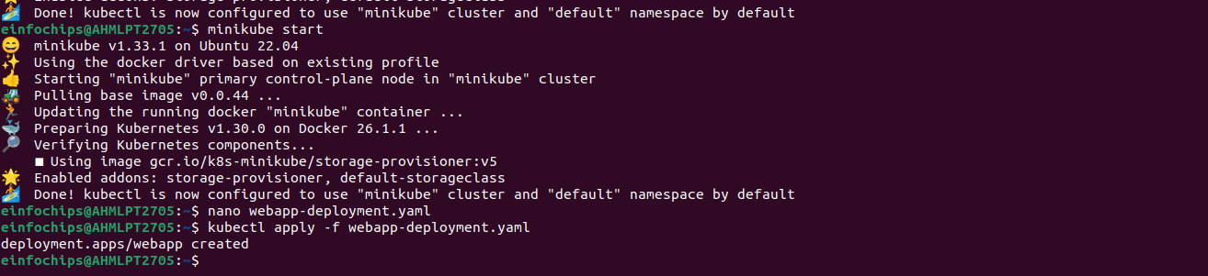

#### **2.3 Expose the Deployment**

### **Step 3: Deploy a Web Application Using Docker Compose**

#### **3.2 Deploy the Web Application**

### **Step 4: Use a Single Shared Volume Across Multiple Containers**

#### **4.1 Update docker-compose.yml to Use a Shared Volume**

#### **4.2 Deploy with Docker Compose**

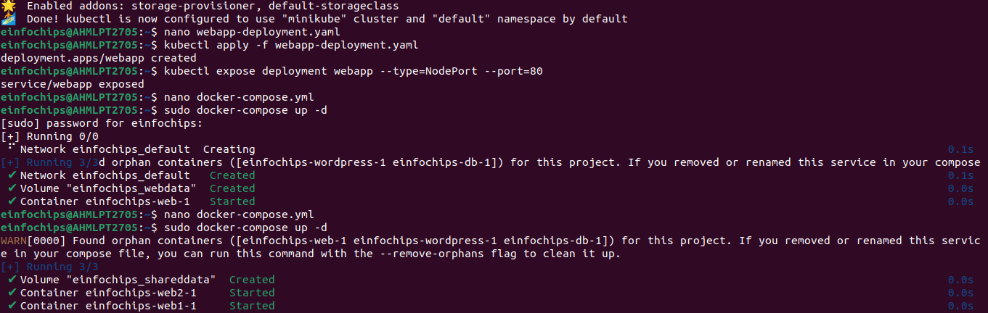

### **Step 5: Automate the Entire Process Using Advanced Shell Scripting**

#### **5.1 Create a Shell Script deploy.sh**

#### **5.2 Make the Script Executable**

#### **5.3 Run the Script**

### 

### 

### 

### 

### **Project 02 - 1 Hour**

### **Comprehensive Deployment of a Multi-Tier Application with CI/CD Pipeline**

### **Objective:**

Deploy a multi-tier application (frontend, backend, and database) using Docker Swarm and Kubernetes, ensuring data persistence using a single shared volume across multiple containers, and automating the entire process using advanced shell scripting and CI/CD pipelines.

### **Overview:**

1. **Step 1**: Set up Docker Swarm and create a multi-tier service.
2. **Step 2**: Set up Kubernetes using Minikube.
3. **Step 3**: Deploy a multi-tier application using Docker Compose.
4. **Step 4**: Use a single shared volume across multiple containers.
5. **Step 5**: Automate the deployment process using advanced shell scripting.

### **Step 1: Set up Docker Swarm and Create a Multi-Tier Service**

#### **1.1 Initialize Docker Swarm**

#### **1.2 Create a Multi-Tier Docker Swarm Service**

Deploy the stack:

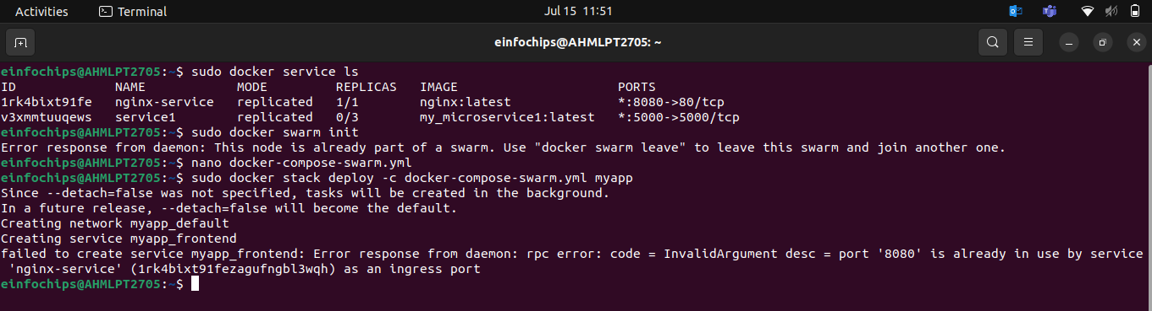

### **Step 2: Set up Kubernetes Using Minikube**

#### **2.1 Start Minikube**

#### **2.2 Create Kubernetes Deployment Files**

Create db-deployment.yaml:

Create shared-pvc.yaml:

Create db-pvc.yaml

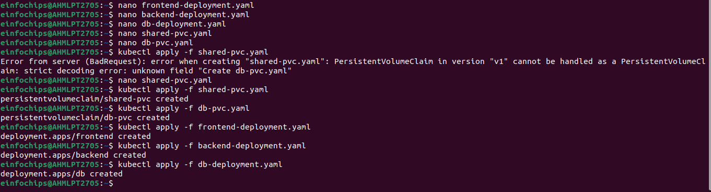Apply the deployments:

### **Step 3: Deploy a Multi-Tier Application Using Docker Compose**

#### **3.1 Create a docker-compose.yml File**

#### **3.2 Deploy the Application**

### **Step 4: Use a Single Shared Volume Across Multiple Containers**

